SIGNALS AND SYSTEMS
Course Code: ECA0305
CO1 – EXPERIMENT 2
Experiment 2.1
Title: Periodic and Aperiodic Signals
Aim:
To generate periodic and aperiodic signals using MATLAB and to distinguish between them based on their repetition property.
Apparatus Required:
- Personal computer
- MATLAB software
Procedure:
- Open MATLAB and create a new script file.
- Clear the command window and workspace using clc, clear and close all.
- Define the time axis t = -5:0.01:5.
- Generate the periodic signal (sine wave) x1 = sin(2*pi*t).
- Generate the aperiodic signal (exponential decay) x2 = exp(-abs(t)).
- Plot both signals in a 2x1 subplot layout with grid, title, xlabel and ylabel.
- Run the program and observe which signal repeats at regular intervals.
- Conclude which signal is periodic and which is aperiodic.
Program:
% Periodic and Aperiodic Signals
clc;
clear;
close all;

% Time axis
t = -5:0.01:5;

% Periodic Signal (Sine Wave)
x1 = sin(2*pi*t);

% Aperiodic Signal (Exponential Decay)
x2 = exp(-abs(t));

% Plotting
figure;

subplot(2,1,1);
plot(t,x1,'LineWidth',2);
grid on;
title('Periodic Signal');
xlabel('Time (s)');
ylabel('Amplitude');

subplot(2,1,2);
plot(t,x2,'LineWidth',2);
grid on;
title('Aperiodic Signal');
xlabel('Time (s)');
ylabel('Amplitude');

Output – Experiment 2.1:
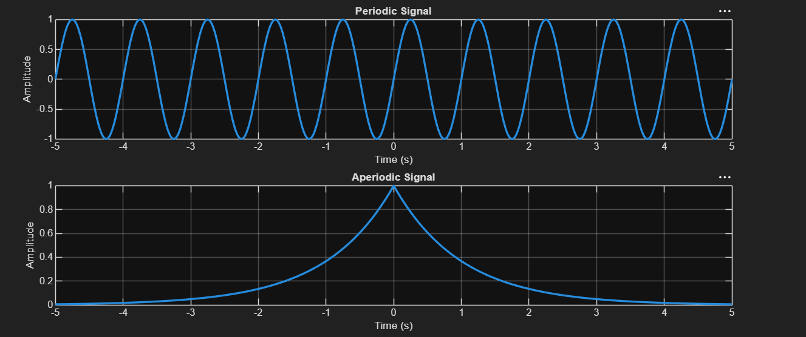
Result:

• Periodic Signal: The sinusoidal signal repeats itself at regular intervals, making it
periodic.
• Aperiodic Signal: The exponentially decaying signal does not repeat, showcasing
that it is aperiodic.
This test case illustrates the key differences between periodic and aperiodic signals by
generating and visually analysing both types using MATLAB.
Experiment 2.3
Title: Amplitude and Time Scaling of Signals
Aim:
To demonstrate the effect of amplitude scaling and time scaling on a continuous-time signal using MATLAB.
Apparatus Required:
- Personal computer
- MATLAB software
Procedure:
- Open MATLAB and create a new script file.
- Clear the command window and workspace using clc, clear and close all.
- Define the time axis t = -5:0.01:5 and the original signal x = sin(2*pi*t).
- Perform amplitude scaling by multiplying the signal by a constant, x_amp = 2*x.
- Perform time scaling by replacing t with 2t, x_time = sin(2*pi*2*t).
- Plot the original, amplitude-scaled and time-scaled signals in a 3x1 subplot layout.
- Add grid, title, xlabel and ylabel to each plot.
- Run the program and compare the three waveforms.
Program:
% Amplitude and Time Scaling of Signals
clc;
clear;
close all;

% Time axis
t = -5:0.01:5;

% Original Signal
x = sin(2*pi*t);

% Amplitude Scaling
x_amp = 2*x;

% Time Scaling (Compression)
x_time = sin(2*pi*2*t);

% Plotting
figure;

subplot(3,1,1);
plot(t,x,'LineWidth',2);
grid on;
title('Original Signal x(t)');
xlabel('Time (s)');
ylabel('Amplitude');

subplot(3,1,2);
plot(t,x_amp,'LineWidth',2);
grid on;
title('Amplitude Scaled Signal 2x(t)');
xlabel('Time (s)');
ylabel('Amplitude');

subplot(3,1,3);
plot(t,x_time,'LineWidth',2);
grid on;
title('Time Scaled Signal x(2t)');
xlabel('Time (s)');
ylabel('Amplitude');

Output – Experiment 2.3:
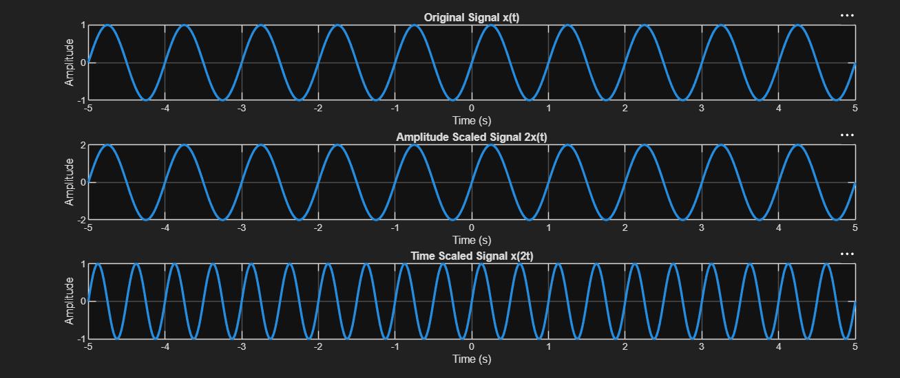
Result:
Scaling affects amplitude or time axis accordingly.

LABORATORY PERFORMANCE ASSESSMENT RUBRICS:

Objective | Assessment Criterion | Excellent – 4 | Good – 3 | Satisfactory – 2 | Needs Improvement – 1 | Weightage | Marks(10) | Marks obtained
(i) Perform amplitude scaling and time scaling of continuous-time and discrete-time signals and analyze their effects on signal characteristics. | Amplitude & Time Scaling Implementation (MATLAB) | Generates the original and scaled versions correctly for CT and DT with correct index handling. Uses plot for CT and stem for DT, with proper time and index vectors. Original and scaled plots are placed in subplots with matching axes, titles, axis labels and grid. | Generates most scaled signals correctly, with minor errors in scaling factors, index handling, axis limits or labelling. | Generates only basic scaled signals, with noticeable errors in code, time or index vectors, or plots, and needs assistance. | Unable to generate the scaled signals or produce meaningful plots. | 25 | 2.5
(i) Perform amplitude scaling and time scaling of continuous-time and discrete-time signals and analyze their effects on signal characteristics. | Analysis of Scaling Effects | Correctly explains that amplitude scaling changes amplitude and energy but not duration or period. Explains that time compression shortens duration and period (T/a) and raises frequency, that expansion does the opposite, and that a < 0 reverses time. Explains that DT scaling discards samples and needs interpolation. Supports every point with waveform evidence. | Explains most effects correctly, with minor errors or limited justification. | Gives basic observations on the effects. The explanation is incomplete and needs guidance. | Unable to analyze or explain the effects of scaling. | 25 | 2.5
(iii) Perform addition and multiplication of two discrete-time sequences and analyze the resulting signal characteristics. | Addition & Multiplication Implementation (MATLAB) | Adds and multiplies two sequences correctly even when their index ranges differ. Aligns the sequences on a common index vector with zero padding, and uses element-wise operator. Plots both inputs and the results with stem, correct n-axis, titles, axis labels and grid. | Performs both operations correctly, with minor errors in index alignment, padding, operators or labelling. | Performs the operations on simple equal-length sequences only, with noticeable errors in code or plots, and needs assistance. | Unable to perform the operations or produce meaningful stem plots. | 25 | 2.5
(iii) Perform addition and multiplication of two discrete-time sequences and analyze the resulting signal characteristics. | Analysis of Resulting Signal Characteristics | Correctly determines the amplitude, the length or range of n, and the energy of the sum and product. Explains the periodicity of the result (for example, the sum is periodic with period equal to the LCM of the two periods). Explains how multiplication acts as gating or modulation. Interprets the results clearly with waveform evidence. | Analyzes most characteristics correctly, with minor errors or limited justification. | Gives basic observations on the resulting signals. The analysis is incomplete and needs guidance. | Unable to analyze or interpret the resulting signals. | 25 | 2.5
 |  |  |  |  | Total | 100 | 10

